**Instructions**

* Save your file as surnameforename.html.
* Use embedded style sheets.
* Once you have completed the exam, email your file to [anne.obrien@staff.ittralee.ie](mailto:anne.obrien@staff.ittralee.ie)
* Do not leave until I have received your exam.
* Please keep a copy of the exam until you get your results back.

**Screen Capture**

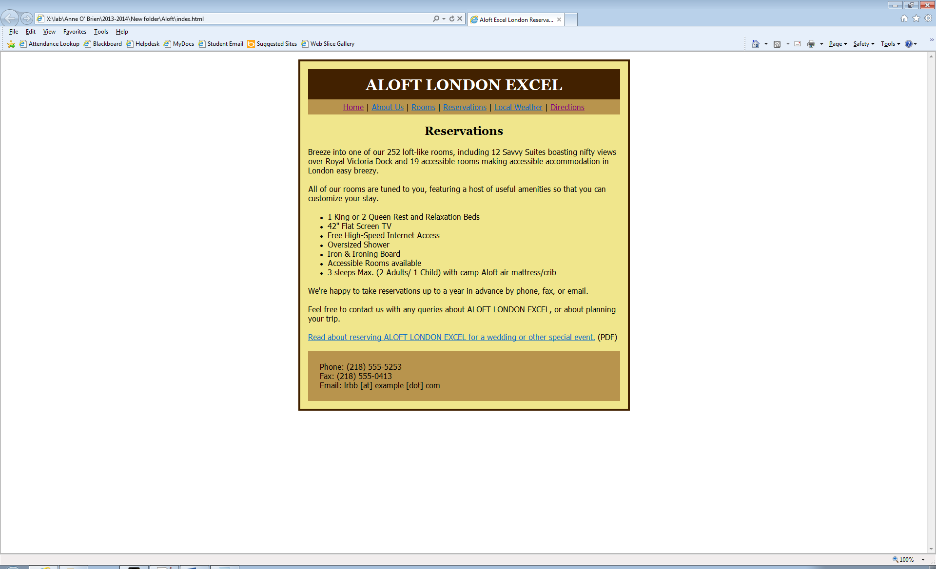

**Links**

Reservations: Based on the chart below and presuming you are in index.html, what would be the relative link to Reservations.html

Directions should to http://www.laterooms.com/en/hotel-directions/246037_aloft-london-excel-london.aspx

Read about reserving ALOFT LONDON EXCEL for a wedding or other special event: Based on the chart below and presuming you are in index.html, what would be the relative link to wedding.pdf

You can leave all the other links blank i.e. have the “ ” empty.

**Text**

# ALOFT LONDON EXCEL

Home | About Us | Rooms | Reservations | [Local Weather](http://www.wunderground.com/cgi-bin/findweather/hdfForecast?query=marble%2C+mn&searchType=WEATHER) | [Directions](http://maps.google.com/maps?f=d&source=s_d&saddr=&daddr=marble,+mn&hl=en&geocode=&mra=ls&sll=37.0625,-95.677068&sspn=32.252269,56.162109&ie=UTF8&z=4)

## Reservations

Breeze into one of our 252 loft-like rooms, including 12 Savvy Suites boasting nifty views over Royal Victoria Dock and 19 accessible rooms making accessible accommodation in London easy breezy.

All of our rooms are tuned to you, featuring a host of useful amenities so that you can customize your stay.

* 1 King or 2 Queen Rest and Relaxation Beds
* 42'' Flat Screen TV
* Free High-Speed Internet Access
* Oversized Shower
* Iron & Ironing Board
* Accessible Rooms available
* 3 sleeps Max. (2 Adults/ 1 Child) with camp Aloft air mattress/crib

We're happy to take reservations up to a year in advance by phone, fax, or email.

Feel free to contact us with any queries about ALOFT LONDON EXCEL, or about planning your trip.

Read about reserving ALOFT LONDON EXCEL for a wedding or other special event. (PDF)

Phone: (218) 555-5253  
Fax: (218) 555-0413  
Email: lrbb [at] example [dot] com

**Settings**

Body font: tahoma, arial, helvetica, sans-serif

Heading font: georgia, "times new roman", times, serif

Some font size used are: 32 24 and 18

Background colours used: #422100, #B8944D, #B8944D, #F0E68C

Other colours include: #422100;

Width of box is 640px